Frame Warden User Guide
by Nathan Warden

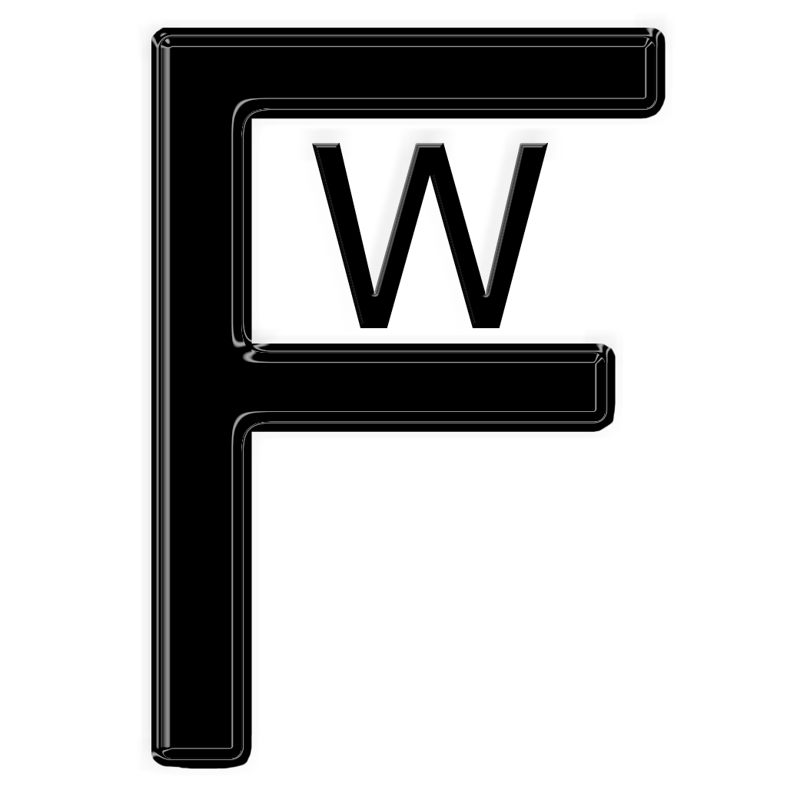

Table of Contents

I. What is Frame Warden?

II. System Requirements

III. Setup & Installation

IV. The Interface

I. What is Frame Warden?

Frame Warden is a render farm controller solution for utilizing Luxology's 3D Animation program, Modo 301 and later on multiple machines to render animations more quickly.

II. System Requirements

The basic system requirements are the same as those for running Modo. If you can run Modo, then Frame Warden can control it. If Modo can't run on your machine, then running a Frame Warden client on that machine will be in vain. You can, however, use a slow, old machine to run the controller from.

III. Setup & Installation

Main Setup:

1) Drag and Drop the "Frame Warden" folder into a common network location so that all computers can see it with all absolute paths being exactly the same.

Example: The controller computer has two drives. It's local (C:) drive and an additional drive (Z:). Drive (Z:) is where the "Frame Warden" folder will go.

So it would possibly be "Z:\Frame Warden\" or "/Volumes/Content/Frame Warden/"
All other computers will have the exact same paths of "Z:\Frame Warden\" or "/Volumes/Content/Frame Warden/" (for instance).

2) Copy the entire Modo 301 or Modo 302 directory to the same common network place. We recommend putting it into the Frame Warden folder.

So it would possibly be "Z:\Frame Warden\Modo 302" or "/Volumes/Content/Frame Warden/Modo 302"

Frame Warden Controller:

1) Start up the Controller application.

2) Open the preferences window via the Apple menu (on a Mac) or the Edit menu (under Windows).

3) Under the General tab, point the Primary Modo Application to the Modo application in your network folder.

So it would possibly be "Z:\Frame Warden\Modo 302\modo.exe" or "/Volumes/Content/Frame Warden/Modo 302/modo.app"

4) If desired, copy a shortcut of the Controller program to the desktop.

Frame Warden Client:

1) Start up the Client application.

2) Input a name into the client name field for this computer.

3) Input the IP address to your controller computer.

4) Set a primary and secondary group if desired.

5) If desired, copy a shortcut of the Client program to the desktop.

IV. The Interface

The Main Window

The Node List: This is a simple list of what nodes are connected to Frame Warden. The list items are describer here from right to left:

Node Name: The name entered in the client for the node.

Status: The stus of the noad (loading scene, rendering, idle)

IP Address: The IP address of the machine the node resides on.

Group: The group(s) the node will render to.

Rendering Scene #: The current scene ID the node is rendering.

Platform: The platform the machine resides on (MacOS or Win).

The Scene List:

Scene Name: The file name of the scene.

Status: The status of the scene (Stopped, Queued, Rendering).

Frame Range: The frame range that will be rendered

Scene ID: The ID automatically given to the scene.

Group(s): The group or groups the scene will render to.

UV to Bake: If the scene is set up for UV baking, the UV map name will be displayed here.

Drag & Drop: Frame Warden supports drag and drop. All you need to do is simply drag the LXO file you want to render into the scene list. The settings window will then pop up and you will be able to set your settings.

The Preferences Window

General: This tab has general settings Frame Warden uses.

Primary Modo Application: This is the path to the copy of modo that will be launched from the node, thus, the node must be able to reach that exact path from the node itself.

Relaunch unresponsive nodes after: If the node isn't responsive to Frame Warden after this amount of time, the Frame Warden Client will restart modo on that machine. This will NOT override the Maximum Frame Time set for the scene. So, although this may be set to 5 minutes, if you set the Max Frame Time for the scene as 60 minutes, it will not restart for 60 minutes. If you set it to 0 it will never restart.

Default max frame time: This is the default amount of time before any given frame will be redistributed if it hasn't finished rendering on the node it was distributed to.

Rendering: This tab has render settings that modo uses.

Allow modo to display render progress?: Do you want modo to display the progress of renders. If set to no, modo will only display the stats bar at the top of the render window.

UV Baking Border Size: This is the amount of space that modo will bake away from the border of the UV map in order to avoid black lines where the UV splits. You must have an alpha channel set in order for modo to make this work.

Geometry Cache Size: You can set the geometry cache size using this setting. This is set in MB. Every 1024 MB is 1 GB, so, if you want to set a cache size of 4 GB, you want to set this to 4096 MB.

Frame Warden License: This is where you'll enter your Frame Warden License if you've purchased one. You can purchase one at www.FrameWarden.com/FrameWarden/Purchase.html

The Scene Setup Window

Basic: This tab has basic scene settings.

Frame Range: This is the range of frames in which to render from. So if you have 1 to 120 by 2, it will render frames 1, 3, 5, 7, etc... until frame 119.

Render Groups: These are the groups the scene will render to. If you want to render them to one group only, then simply set them both to the same group. The reason there are two groups available is so you can have a group of fast machines, mediocre machines, and slow machines. If you have a scene that needs to render soon, you can set it to groups 1 and 2. If you want to render a slow scene, but not too slow, you can set it to 2 and 3. That way, you won't have unimportant scenes rendering on fast machines, but, you don't have to keep them only on the slowest machines.

Max frame time: This is the amount of time before a frame will be redistributed to another node if it hasn't rendered by this time.

Check for rendered frames: If this is checked as true, Frame Warden will check to see which images have been rendered and which ones haven't.

Output: This tab has output settings for the frames rendered.

Use modo outputs: If you have internal settings for the scene for the render outputs, this option will let modo save out the files to those locations.

Layered: This option will let you save to a layered output file such as PSD, EXR, and Multiple PNG's

Use a custom output path: This option will allow you to set a custom output path for the images. Be sure NOT to include a three letter extension as modo will add this itself.

Bake UV: This tab has options for using modo's UV baking.

Bake UV map: Check this on if you want to use UV Baking

Select UV to bake: This has a drop down menu of the available UV maps. The final option is “* Bake All Maps”. If this option is selected, Frame Warden will go through each UV map and make a new scene per UV to bake. It can take a while if you have many UV maps.

